**Stover Desktop App User Guide**

**What is Stover?**

Stover is a **desktop app** that classifies **green canopy cover, residue cover, and bare soil** from downward-facing images taken with cameras or mobile devices.

Stover was trained with images from corn, sorghum, soybean, sunflower, and wheat fields but may also work in other crops. For the most accurate residue estimates, collect images when little or no live vegetation is present. Take **photos about 2 to 3 ft above the ground**, this helps capture fine residue details. If you need more area coverage, take more photos instead of raising the camera higher.

**Installation**

1. Download Stover for Windows: soilwater.github.io/stover
2. Double-click the downloaded file and follow the prompts to install.
3. Launch Stover from your desktop (it may take a moment to open). We recommend a computer with a minimum of 64 GB of RAM.

**How to Use Stover**

1. Load Images
   * Go to the Inputs tab and click Load images to upload your photos.
   * You can also test with example images included in the app.
   * Use the slider to preview the automatic classification (residue, canopy, soil).
2. Set Outputs
   * In the Outputs tab, choose a folder to save results.
   * Add a field name and optional comments (e.g., weather, residue type, location).
   * Select your output format: CSV spreadsheet, PDF report, or classified images.
3. Process Images
   * Click Process batch to classify and save results for all uploaded images.

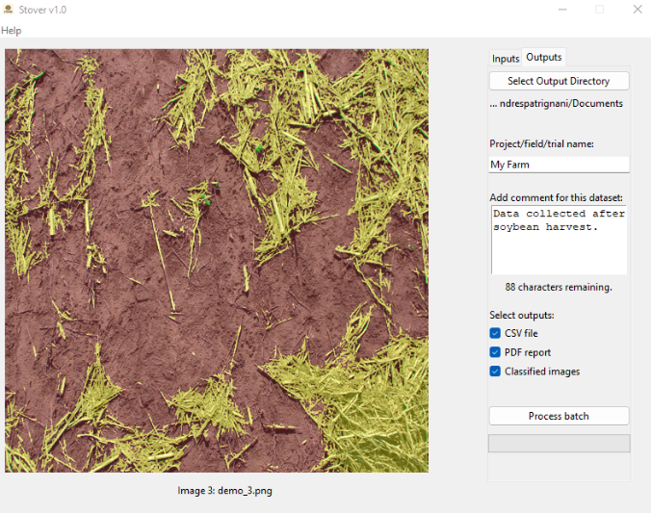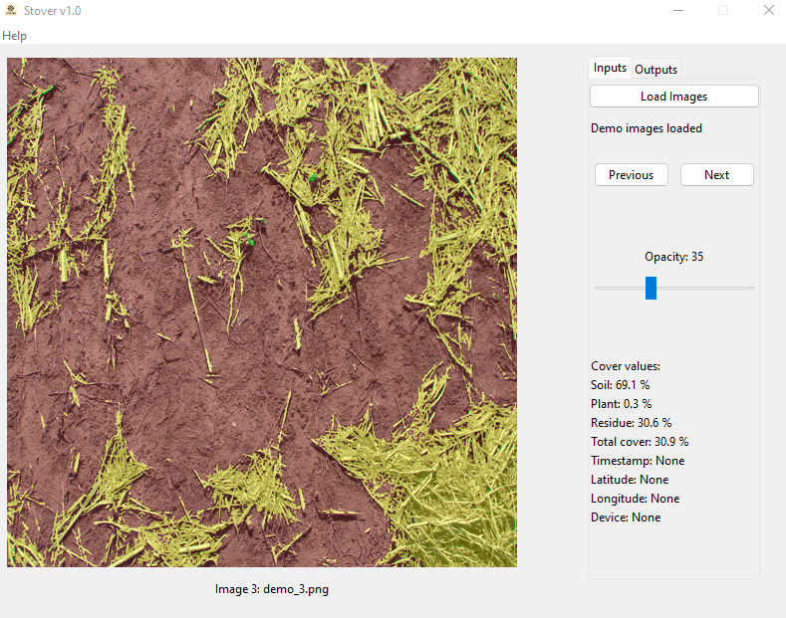

Figure showing the “Inputs” tab (left) and the “Outputs” tab (right) of the Stover app.

For questions and feedback, contact Andres Patrignani at [*andrespatrignani@ksu.edu*](mailto:andrespatrignani@ksu.edu)

Associate Professor in Soil Water Processes, Department of Agronomy, Kansas State University

Guide created on 25 September 2025